**AMAZON ATHENA**

* Serverless query service to perform analytics against S3 objects
* Uses standard SQL language to query the files
* Supports CSV, JSON, ORC, Avro, and Parquet (Athena is built on Presto)

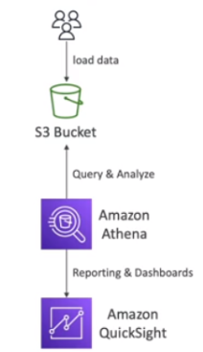

* Pricing: $5.00 per TB of data scanned
* Use data in compressed of columnar data for cost-saving (less scan)
* Use cases – business intelligence, analytics, reporting, analyse, & query VPC flow logs, ELB logs, CloudTrail trails, etc

**Exam Tip:** analyse data in S3, using serverless SQL, use Athena